DATEROEM WOOD SALES
System Documentation
Mobile Application
The staff Android app: sections, screens, roles and builds
Document | Mobile Application
Document number | DWS-MOB-02
Version | 1.1
Date | 24 October 2026
Intended readers | Developers and maintainers; administrators for the section and role overview
Classification | Internal - contains system design details; share only with authorised staff
Describes the Dateroem Wood Sales Android app used by staff: how it is organised, every section and screen with its source files, role access, the voice assistant, company-SIM SMS reading, network settings, and how to build, test and share it.

Document control
Version | Date | Change
1.0 | 3 October 2026 | First complete edition, written from the source code as it stood on this date.
1.1 | 3 October 2026 | Added one approved phone per account (admin approval of new phones) and the fingerprint app lock.
1.1 | 4 October 2026 | Campaign products picker, kept media and drafts on the campaign form, video stills in campaign lists; microphone permission for voice; the app lock covers the open screen instead of replacing it.
1.1 | 5 October 2026 | New phones are approved by the SuperAdmin; the blocked-phone message names the SuperAdmin (from the next APK).
1.1 | 9 October 2026 | Products: Retire / Bring back for admins, retired products marked, a "Needs attention" banner and a count on Products in the menu for out-of-stock products; customer accounts can no longer sign in to the staff app.
1.1 | 9 October 2026 | Marketing: Bulk order pictures (add, caption, order and remove the website's Bulk Orders slideshow; Marketers, Admins, SuperAdmin). Retire moved inside the product form; Bring back stays on the list.
1.1 | 18 October 2026 | The entrance in real photographs (the old oak, mist, a misty pine forest) with the company emblem; sign-in in the same forest; the app icon is the company emblem.
1.1 | 18 October 2026 | Calm error messages on every screen (friendlyError).
1.1 | 18 October 2026 | The entrance also replays when the app comes back from the background after more than 15 minutes, over the screen the person was on.
1.1 | 19 October 2026 | The entrance plays every time the app is opened afresh, and after 3 minutes away in the background; sign-in in the app's green wash, the entrance dissolving into it.
1.1 | 20 October 2026 | The mist in three seamless layers at different depths, livelier and more visible.
1.1 | 20 October 2026 | The "Living Forest" colours, chosen by the board for a livelier green, the same as the website and desktop app (screens, sign-in fallback, app lock).
1.1 | 20 October 2026 | Colour themes (Forest, Dark, Light) in Settings, behind a bold gear beside Sign out; Sign out asks first; turning the phone no longer asks for the fingerprint.
1.1 | 23 October 2026 | Orders are named by their ticket (DW-7K3Q9P); Share driver when assigning orders and on a trip's light deliveries (Managers and admins).
1.1 | 24 October 2026 | My profile from the photo and name at the top of the menu; Choose a new password after an admin's reset; the idle lock with Still there?.
1.1 | 24 October 2026 | Home: the business at a glance for Admins and the SuperAdmin, profit and expenses for them only, the company card from the server (SuperAdmin edits); Orders: due-soon and late marks.
1.1 | 24 October 2026 | Worker details from My profile: the staff member's ID and other numbers, next of kin, and document photos from the camera or gallery; where it stands and the SuperAdmin's note.
1.1 | 24 October 2026 | Editing a delivery area on the phone no longer empties its map pin (the backend keeps it).
1.1 | 24 October 2026 | Error messages in their own scrolling box (ErrorBox), and why the USB test copy can't reach the server once unplugged.
Keep this document up to date: when a feature, setting or server changes, edit the matching section here and add a line to the table above.
Contents
1 Introduction 4
2 Source layout 6
3 Navigation and roles 7
4 Sections and screens 8
4.1 Splash, sign-in and Home 8
4.2 Orders 9
4.3 Products 9
4.4 Bulk orders and delivery areas 9
4.5 Marketing 10
4.6 Trips and light deliveries 10
4.7 Trees 11
4.8 Expenses 11
4.9 Transactions 11
4.10 Loans & Finance 11
4.11 AI assistant and insights 11
5 Voice assistant 12
6 Company SIM payment reading 13
7 Look and feel 14
8 Phone approval and app lock 16
8.1 Worker details 16
8.2 One approved phone per account 16
8.3 Fingerprint lock 16
9 Network settings 18
10 Building, testing and sharing 19
10.1 Testing on the USB phone 19
10.2 Command-line builds 19
10.3 Sharing the app with admins elsewhere 19
10.4 Before a production release 19
11 Development history 20

1 Introduction
The mobile app is the main working tool for staff in the field: registering trees and farmers, recording expenses, running trips and deliveries, managing products and campaigns, collecting and sending M-Pesa payments, and asking the assistant for help. It talks only to the mobile server (DWS-MOB-01).
Item | Detail
Project folder (Windows) | C:\Users\PC\AndroidStudioProjects\DateroemWoodSales
Application id | com.dateroem.woodsales - version 1.0 (versionCode 1)
Android versions | minimum SDK 24 (Android 7.0), target SDK 35, compile SDK 36
Language and UI | Kotlin 2.2 with Jetpack Compose (Material 3), always dark
Networking | Retrofit 2.9 with Gson, OkHttp 4.9 (adds the sign-in token)
Other libraries | Navigation Compose, DataStore (session), Coil (images), Media3 ExoPlayer (videos), SplashScreen, ExifInterface, AndroidX Biometric 1.1 (fingerprint lock)
Wiring | Manual dependency setup in AppContainer.kt; one ViewModel per screen

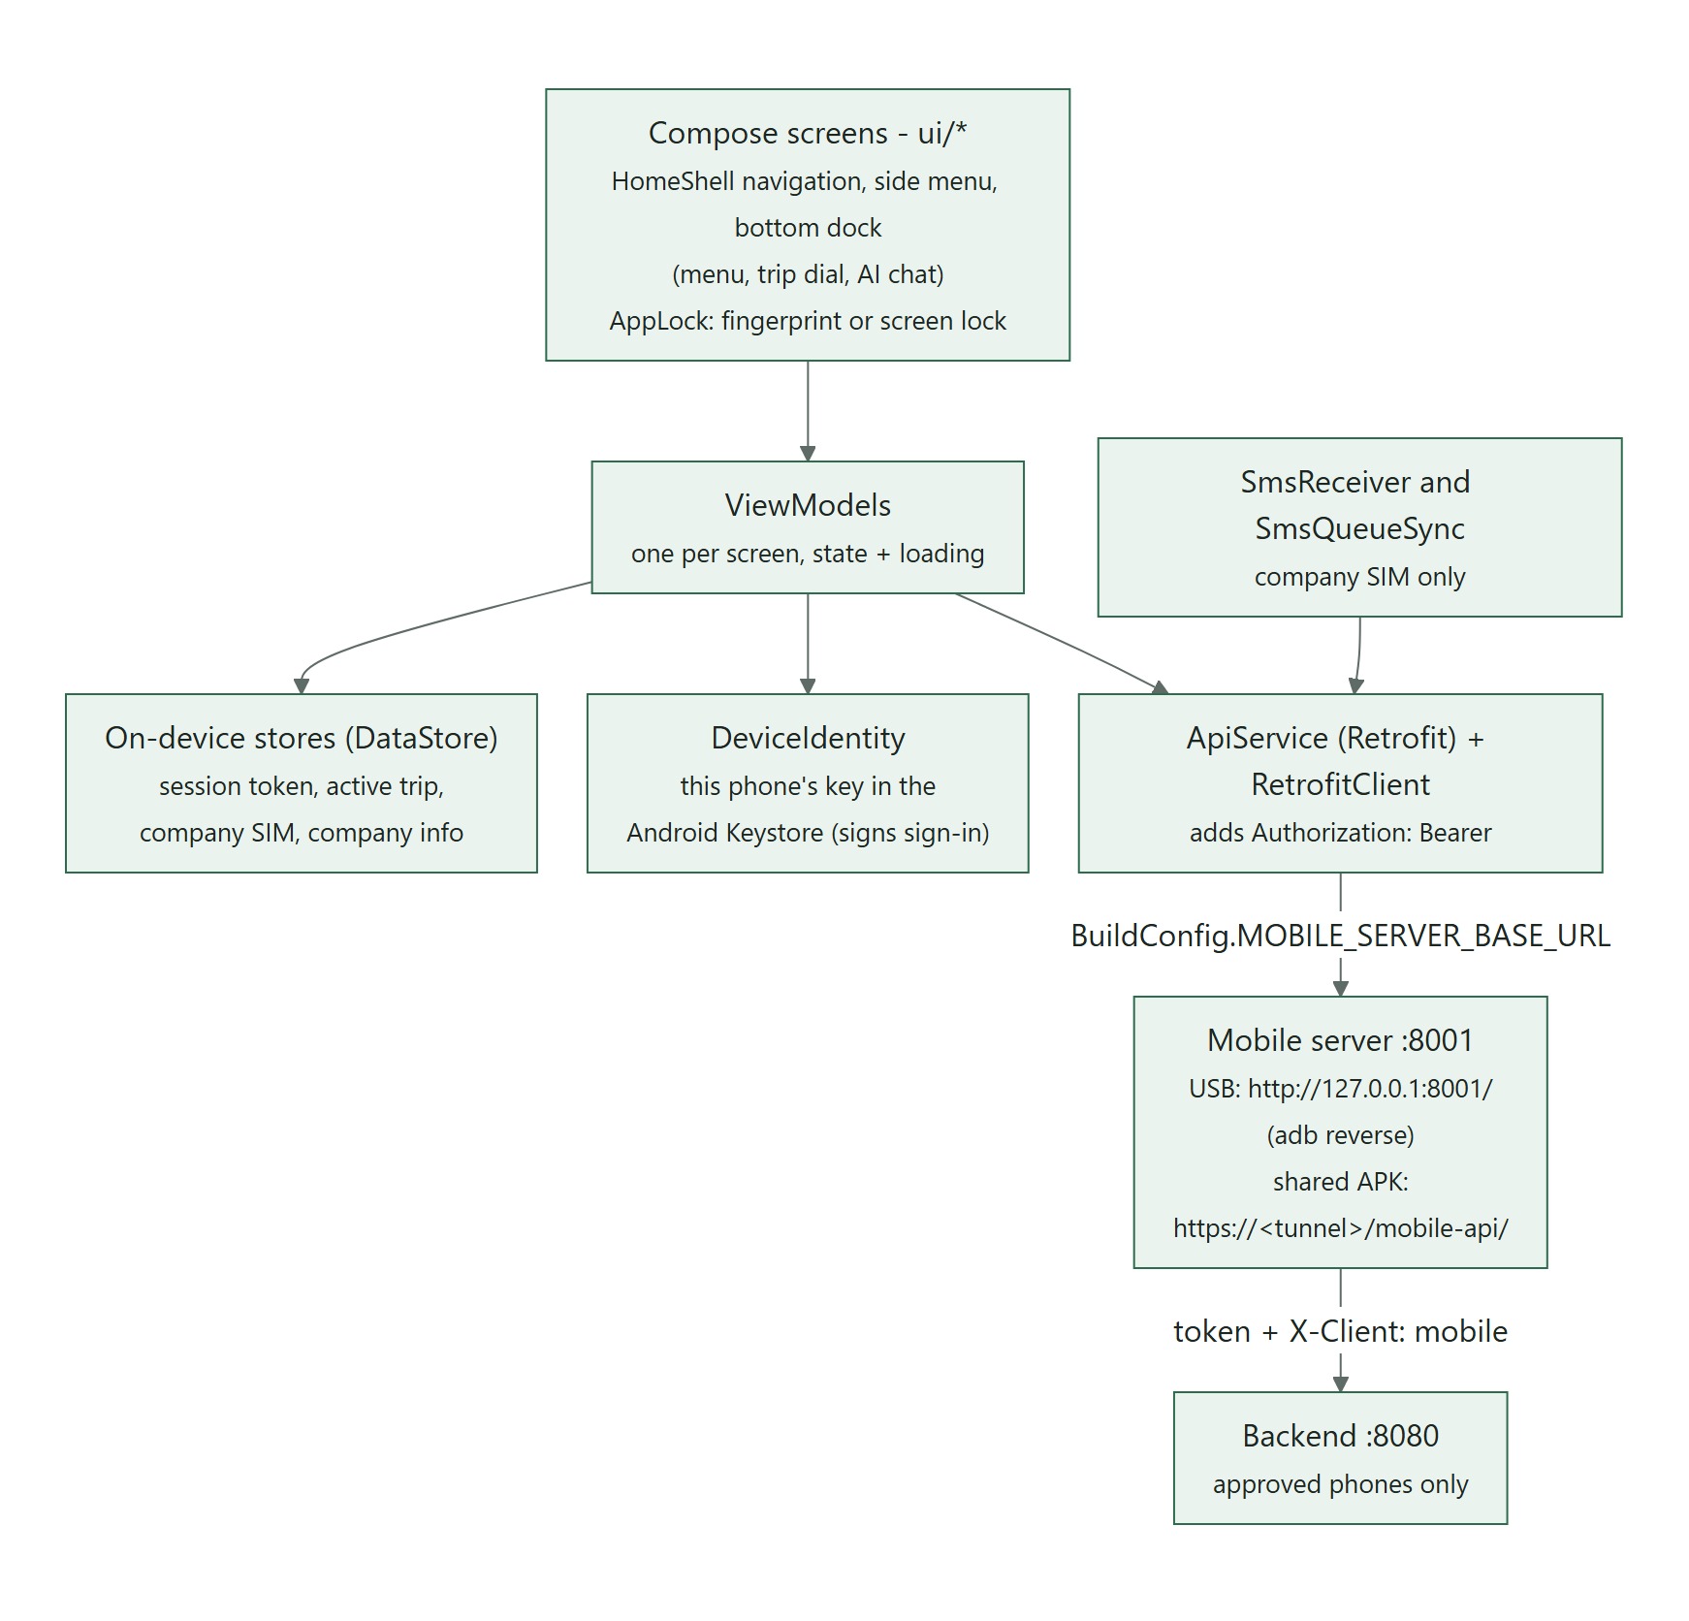
Figure 1: How the app is organised

2 Source layout
Code is under app/src/main/java/com/dateroem/woodsales/.
Folder | Contents
MainActivity.kt, AppContainer.kt | Start-up (system splash hand-off) and shared objects. MainActivity is a FragmentActivity because the fingerprint prompt needs one.
data/security | DeviceIdentity: this phone's key in the Android Keystore, used to prove which phone is signing in
data/network | ApiService.kt (every server call), RetrofitClient.kt (base address, token, time-outs)
data/model | Typed request and response classes (products, trees, trips, expenses, campaigns, loans, AI chat ...)
data/session | SessionManager (sign-in, splash replay), ActiveTripStore (trip picked on the dial), CompanySimStore, CompanyInfoStore
data/sms | SmsReceiver, MpesaSmsParser, SmsQueueSync (company SIM payments)
data/media | ImageCompressor (resize and rotate photos before upload)
ui/nav | HomeShell (all routes), Destinations (sections and roles), AppDrawerContent (side menu), BottomDock, AppRoot
ui/<section> | One folder per section: dashboard, orders, products, bulkorders, marketing, trips, deliveries, trees, expenses, transactions, finance, shipping, ai, auth, splash
ui/common | Shared pieces: AppIcons, pickers (farmer, tree, machine, vehicle, date), voice assistant, video player, video stills, location helper
ui/theme | Colours, type, wood images. Since 20 October 2026 the "Living Forest" greens (DateroemBackground #0F241B, DateroemSurface #1D4232 in Color.kt; forest_dark and forest_mid in res/values/colors.xml), the same as the website and desktop
ui/settings | SettingsScreen - Appearance: Forest, Dark or Light (since 20 October 2026)
res/xml/network_security_config.xml | Which plain-HTTP addresses are allowed (development only)

3 Navigation and roles
After sign-in the app opens on Home. The side menu lists only the sections the person's role may open. A bottom dock holds the menu shortcut (left), the wooden trip dial (centre) and the AI assistant (right). The trip picked on the dial becomes the active trip that Home and every trip-based section follow.
Section | Roles that see it | Main file(s)
Home | Everyone | ui/dashboard/DashboardScreen.kt
Orders | Manager, Admin, SuperAdmin | ui/orders/OrdersScreen.kt, AssignGroupScreen.kt
Products | ProductStaff, Worker, Manager, Admin, SuperAdmin | ui/products/*
Bulk Orders | Marketer, ProductStaff, Worker, Manager, Admin, SuperAdmin | ui/bulkorders/*
Marketing | Marketer, Manager, Admin, SuperAdmin | ui/marketing/*
Trips | Manager, Admin, SuperAdmin | ui/trips/*
Trees | ProductStaff, Worker, Manager, Admin, SuperAdmin | ui/trees/*
Expenses | Worker, Manager, Admin, SuperAdmin | ui/expenses/*
Transactions | Manager, Admin, SuperAdmin (STK push open to all) | ui/transactions/*
Loans & Finance | Admin, SuperAdmin | ui/finance/*
AI assistant | Everyone (answers are role-aware) | ui/ai/*
Table 1: Sections and who can open them (ui/nav/Destinations.kt)
Where to adjust: Section access: requiredRoles in ui/nav/Destinations.kt. Finer rules inside screens (bins, Pay, Assign) check whether the user is Admin or SuperAdmin. Remember that these are screen rules only; the backend enforces admin rights only for the actions listed in the Backend Server document.

4 Sections and screens

4.1 Splash, sign-in and Home
Error messages (24 October 2026, "some errors are kind of long and they do not well cover the space some go over other thins so can we fix this such if the error apperas the space can e.g be scrollable"): every error the app shows - a form that couldn't save, a screen that couldn't load, sign-in, payments, the assistant - sits in ui/common/ErrorBox.kt: tinted red, at most about four lines tall (three for small notes), scrolling inside itself with a thin bar when the message is longer, so a long message never pushes the screen around or slides under the floating assistant button. The short titles ("Couldn't load products") and the red Delete buttons stay as they were.
Home since 24 October 2026 (ui/dashboard/): the company card comes from the server - the same on every phone, kept on the phone for when it is offline - and only the SuperAdmin sees Edit. Admins and the SuperAdmin also see the business at a glance (/insights/overview): the orders waiting for a delivery with how many are past or close to the promised date, users by role, products, campaigns and trips. With a trip picked, everyone sees products sold and deliveries; profit and expenses only Admins and the SuperAdmin ("Admins and SuperAdmin only").
Since 24 October 2026 the photo and name at the top of the menu open My profile (ui/profile/ProfileScreen.kt): the photo (tap it to choose one from the gallery - shrunk on the phone, cut square by the phone server), the name, the email (hidden until Show; the password is asked for when it changes), the phone number (hidden until Show; an admin changes it, because payouts go to it) and the password (this phone stays signed in; every other device is signed out). After an admin's password reset, Choose a new password (ForcedPasswordScreen.kt) comes before Home. The idle lock: open but untouched for the SuperAdmin's minutes (25 at first), the app asks for the fingerprint, with Still there? a minute before (AppLockGate, MainActivity.onUserInteraction); Settings says how many minutes.
- SplashScreen - since 18 October 2026 two real photographs instead of the drawn forest ("the board has seen it wise to use a real forest"): the old oak rises out of the dark, mist rolls in and clears over a misty pine forest, then the company emblem, the wood wordmark and "Growing Timber, Growing Futures" settle in (about 6 seconds; a tap skips it; with the phone's animations off, the last picture for a moment). It plays every time the app is opened afresh - after it was closed (swiped away from the recent apps) or Android cleared it (since 19 October 2026: "like other apps like netflix"). Coming back from the background (Home, Back or another app) it plays again only after more than 3 minutes away (15 until 19 October 2026), over the screen the person was on, which is still there afterwards, and the fingerprint prompt waits until it ends. Turning the phone does not replay it. In its last moment the app's own greens wash over the forest.
- LoginScreen - username and password with the tree-ring wordmark, in the same misty forest the entrance ends in (since 18 October 2026). Since 19 October 2026 it is the entrance's last picture without the brand - the same mist carrying on (since 20 October 2026 in three seamless layers that thicken, thin, rise and settle like real mist), the same shade and the app's green wash - and the entrance dissolves into it instead of cutting. When the phone waits for approval it shows a card naming the phone and a "Check again" button; after being signed out it shows the reason (see Phone approval and app lock).
- Lock screen (ui/auth/AppLock.kt) - asks for the fingerprint or screen lock before Home is shown, except straight after signing in.
- DashboardScreen - for the active trip: expenses, products sold, deliveries, running campaigns; profit for admins; editable company details (kept on the phone).

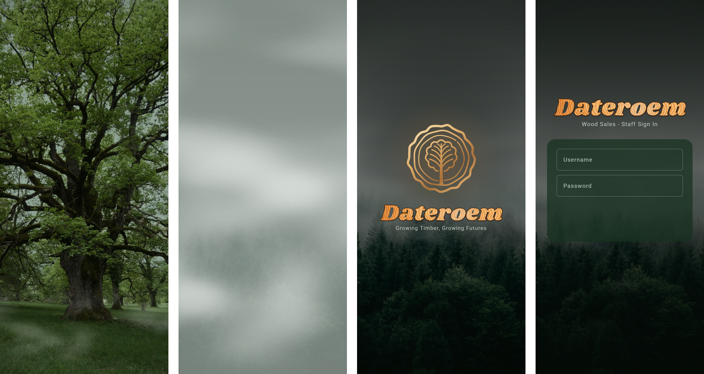
Figure 2: The entrance: the oak, the mist, the forest with the emblem - then sign-in in the same forest (drawn from the app's own pictures and timings)

4.2 Orders
Since 24 October 2026 an order still waiting for a delivery is marked as its promised date comes near: DUE SOON (orange) in the last quarter of the promised time, never later than 5 days before, and LATE (red) once the date has passed - on the customer's card, on each order and in Assign - so it goes on a delivery that arrives by then.
Website orders not yet on a delivery, one card per customer and delivery area, marked LIGHT, BULK or COMBINED by size. Open a card to send the orders to a trip: choose an existing delivery or a new (optionally named) one, untick orders to leave pending, confirm - or add to an existing batch. Drop takes an order off with a cancellation cost; its refund then waits in Transactions > Refunds.

4.3 Products
Product list with photos; the round + adds a product: name, type, price, stock and unit (pieces or board feet), photo (camera or gallery, compressed on the phone and uploaded), the tree registration it came from, marketer badge and description. Tap to edit or delete; deleted products go to the bin in the top bar, where admins restore them. If Android closes the app while the camera is open, the photo still arrives when the app comes back (the camera hand-off is saved with rememberSaveable).
Retiring (admins, since 9 October 2026): open the product and press Retire Product near the bottom of its form (kept inside the product so it isn't pressed by mistake from the list); it asks first, then goes back to the list. A retired product's card turns brown with "Retired - hidden from the shop" and a Bring back button, stays in the list and keeps its stock and orders; its form says "Retired - hidden from the shop. Bring it back from the product list." When products run out of stock, a "Needs attention" banner at the top opens the out-of-stock list, and the menu shows the count beside Products. Needs a new app build to reach the phones.

4.4 Bulk orders and delivery areas
Heavy orders of the active trip. + opens a new heavy order (company name). The detail screen records production description lines (type, measurements, total body feet, product total, optional photo), the payment as hard or soft cash (with an STK push for the soft part), and "Mark as delivered"; amounts stay editable afterwards. "Delete order (negotiation failed)" removes one. The pin icon manages delivery areas (city, pickup point, hours, active).

4.5 Marketing
Campaign list showing each photo, or for a video a still taken from it with a play mark, so campaigns are easy to tell apart. + creates a campaign with a name, channel (radio buttons, or All), status, dates, one media item (take photo, record video or choose from gallery) and the products it promotes. Videos play in the app. Deleted campaigns go to the bin.
- Products in this campaign - a field on the form opens a searchable list of products to tick ("None chosen yet - tap to choose" until some are). Saving replaces the campaign's whole set in one request. An Active campaign with no products shows the hint "Customers only see a campaign on the website once it has at least one product."
- Media is kept - editing a campaign without choosing a new photo or video keeps the existing one. (The server sends the media as media/campaigns/...; mediaKeyOf turns it back into the stored key before saving.)
- Unsaved changes are kept - leaving the form, or the app locking, keeps what was typed as a draft for as long as the app runs. Coming back shows "Your unsaved changes from before are back." with a Discard button; Cancel throws the changes away.
- Video stills - ui/common/VideoThumbnail.kt takes the picture at 0.8 seconds into the video, keeps recent ones in memory and saves them in the app's cache folder (video_frames), so a list opens quickly the next time. Used through ui/marketing/CampaignMediaThumbnail.kt in Campaigns and Deleted Campaigns.

Bulk order pictures (since 9 October 2026): the picture button in the Marketing top bar - Marketers, Admins and the SuperAdmin only - opens the photos that play as a slideshow on the website's Bulk Orders page. Each shows whole on a 16:9 card with its number and caption; arrows move it earlier or later, Add caption / Edit caption and Remove (asks first) sit under it. The round + takes a photo or picks one from the gallery, then asks for an optional caption (up to 120 characters) before adding it; the photo is shrunk on the phone (1600 px JPEG) and uploaded. 12 at most - the + disappears at 12. Files: ui/marketing/ShowcaseScreen.kt, ShowcaseViewModel.kt, data/model/Showcase.kt.
Files: ui/marketing/CampaignsScreen.kt, CampaignFormScreen.kt, CampaignFormViewModel.kt (drafts, mediaKeyOf), CampaignProductsPicker.kt, CampaignMediaThumbnail.kt, DeletedCampaignsScreen.kt.

4.6 Trips and light deliveries
Since 23 October 2026 orders are named by their ticket (like DW-7K3Q9P) everywhere in the app - the ticket the customer quotes. Customers no longer see the driver or the vehicle unless it is shared: when sending orders to a new delivery, tick Share the driver with the customer; orders joining an existing delivery follow that delivery. On a trip's light deliveries, Managers, Admins and the SuperAdmin have a Share driver with customers switch on each delivery. Shared, the customer sees the driver's first name, the number plate and the company phone - never the driver's own number.
- Trips list with the active (open) trip highlighted. A new trip can be created only when no other trip is open; it becomes the working trip once picked on the dial.
- Trip detail: key figures (deliveries, permits, loans plus capital) and Finalize Trip, which also records the remainder trees left over.
- Light deliveries of a trip: tap a delivery, enter "Received by", let the customer sign on the screen, confirm "Yes, delivered". If some orders were not delivered, give the reason; they return to Orders as priority.

4.7 Trees
Registrations of the active trip. + registers trees: an existing farmer (searchable picker) or a new farmer with name and phone, household, number and type of trees, and GPS coordinates filled from the phone's location (works offline). Remainder trees can name the tree registration they came from. Deleted registrations go to the bin.

4.8 Expenses
Pick a trip, then a category (transport, permits, communication, salaries, farmer payments, machine, accommodation, other) to see its total. The list toggles between all, paid (assigned) and pending entries. + adds an entry: amount, description, paid with soft cash (M-Pesa) or hard cash, and the category's own fields (vehicle or machine picked from lists, who it is for, farmer and tree). Admins press Pay to send it with Send Money.

4.9 Transactions
Screen | Purpose
Send STK Push | Collect money from a customer's phone (open to every signed-in user)
Assign / View all unassigned | Claim incoming payments and assign each to the entry it paid for (admins)
Send Money (from an entry) | Pay an entry: details pre-filled, review in bold, transfer animation, automatic receipt
Refunds | Dropped orders owed money; pay each like Send Money
SMS Sync | Company phone only: choose the company SIM once, then resync the inbox

4.10 Loans & Finance
Admins only. Loans of the active trip with paid and remaining amounts, add or edit a loan, open a loan to see repayments (paid or pending M-Pesa) and Pay Loan. Capital shows the trip's capital entries and the hard and soft cash split (Save Split, Recalculate Total).

4.11 AI assistant and insights
The orb in the bottom dock opens a compact chat card. Answers follow the person's role and can include a button that opens the right screen. The clock icon shows past conversations by date. Admins also have insight screens (unassigned transactions, top farmers, expense breakdown) that chat answers can link to.

5 Voice assistant
Forms can be filled by voice. Turn the voice assistant on, tap a field and speak; the field fills, then tap the next field. Saying "stop" or switching the assistant off ends listening. Number words become digits ("two hundred Kenyan shillings" gives 200), and the keyboard stays hidden while voice is on unless the person chooses to type. It uses Android's built-in speech recognition, so there is no extra cost.
Voice needs the microphone permission. The app asks for it when voice is switched on or a field's microphone is tapped, and then carries on with what was asked. If the permission is refused - or Android no longer asks because it was refused before - a notice appears under the switch (or under that field) instead of nothing happening: "Voice needs the microphone, and it's switched off for this app. Allow it under Permissions > Microphone.", with an Open settings button that opens the app's settings page.
The manifest declares the speech recognition and text-to-speech services the app uses (<queries>), which Android 11 and later require before an app may reach them.
Files: ui/common/VoiceAssistant.kt, ui/common/VoiceInput.kt, AndroidManifest.xml.

6 Company SIM payment reading
- Only the account an admin marks "can sync SMS" (one account in the whole system) sees the SMS Sync screen.
- On that phone, the company SIM is picked once (CompanySimStore); messages from any other SIM are ignored.
- SmsReceiver is registered in the manifest, so it runs even when the app is closed. MpesaSmsParser reads the receipt, amount, type and balance; SmsQueueSync posts the message to the mobile server.
- Permissions used: RECEIVE_SMS, READ_SMS and READ_PHONE_STATE (to tell the SIMs apart).

7 Look and feel
- Colour themes (since 20 October 2026): Forest (the default), Dark (charcoal greys) and Light (warm paper, dark text, a darker wood for small text), chosen in Settings - the bold gear beside Sign out at the foot of the menu ("instead of writing settings just place the bold icon"). The colour names in ui/theme/Color.kt read DateroemThemeState, which is Compose state, so a change recolours every screen at once without rebuilding anything or asking for the fingerprint. The choice is kept on the phone (SessionManager) and with the account (PUT /auth/me/theme); when Home opens the app takes the account's - unless a choice made offline is still waiting, which is sent instead. An app that is already open is not changed by a choice made on another device until it is started again ("no one is affected when working"). The entrance and sign-in keep the forest colours of their photographs.
- Dark forest theme with the same painted wood as the website (images in res/drawable-nodpi, produced by the website's npm run wood:export).
- Line icons from ui/common/AppIcons.kt - the same set as the website and the desktop app (a tree-ring cross-section marks Products). No emojis.
- Money transfers show a green transfer animation (ui/transactions/TransferAnimation.kt).
- Errors (since 18 October 2026): every screen turns a failure into one plain sentence with friendlyError (ui/common/ErrorMessages.kt) - the server's own reason when it wrote one, otherwise "Can't reach the Dateroem server. Check your internet connection ...", "The server took too long ...", "The Dateroem server is offline for a moment ..." or "Something went wrong on our side ..." - never an address, an exception name or an HTTP code.
- The entrance and sign-in stand in real photographs (ui/common/Entrance.kt; res/drawable-nodpi: entrance_oak, entrance_forest and the drifting mist entrance_fog). They were prepared from the board's pictures, kept with the script that made them in fathersProject/brand/entrance photos (prepare_entrance.py).
- The app icon is the company emblem - the website's own icon - written by the website's npm run brand:export -- --mobile <this project>/app/src/main/res: an adaptive icon with a one-colour version for themed icons, and older-phone icons. The system start screen shows it on a dark disc.

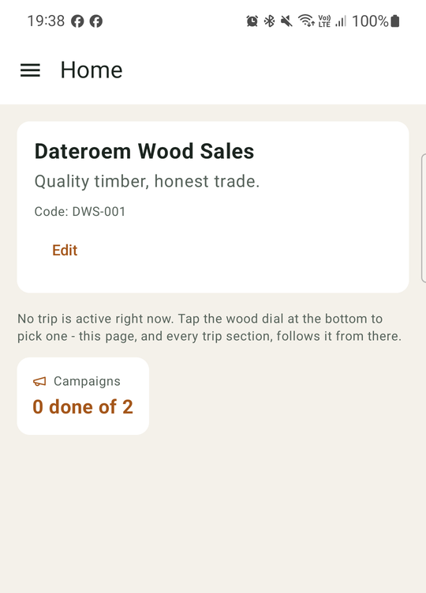
Figure 3: Home in the Light theme

8 Phone approval and app lock
Added on 3 October 2026. Two separate protections work together: the server allows each account on one approved phone only, and the app asks for the owner's fingerprint or screen lock before showing anything.

8.1 Worker details
Since 24 October 2026 My profile has Worker details (ui/profile/WorkerDetailsScreen.kt, WorkerDetailsViewModel.kt): the staff member fills in their ID or passport number, KRA PIN, NSSF and SHA numbers, next of kin, driving licence and photos of their documents. Numbers are hidden until Show numbers; required items are marked *. Each document has Take photo (the camera, through the app's FileProvider; the picture stays in the app's cache and is deleted after sending) and Choose from gallery; the phone shrinks it and the phone server turns it upright before it is sent. The top card says where it stands - Not sent yet, Waiting for the SuperAdmin to check, Verified, or Needs changes with the SuperAdmin's note - and that only the SuperAdmin can open them. The fields and documents come from the server, so new ones the SuperAdmin adds appear without a new app.

8.2 One approved phone per account
- On the first sign-in data/security/DeviceIdentity.kt creates a private key named dateroem_device_key in the Android Keystore (in the StrongBox chip when the phone has one). It cannot be read or copied, not even by the app.
- Signing in (ui/auth/AuthViewModel.kt): ask the server for a one-time value, sign it with the key, then send it with the username and password. The server approves an account's first phone automatically; any other phone waits.
- A waiting phone sees "Waiting for approval" with its model name. Once the SuperAdmin approves it in the desktop app (Users > Phones; since 5 October 2026 only the SuperAdmin can), the person taps "Check again" and is signed in.
- If the SuperAdmin blocks or replaces the phone, or an admin disables the account, the next request is refused. SessionGuardInterceptor in data/network/RetrofitClient.kt then ends the session and the sign-in screen explains why, instead of every screen showing its own error.
- Only staff can sign in (since 9 October 2026): a customer account gets "This app is for staff. Please use the website to shop and track your orders." and no phone is recorded for it.
- Uninstalling the app or clearing its storage deletes the key. The phone then counts as a new phone and needs the SuperAdmin's approval again (with replace).

8.3 Fingerprint lock
- The lock covers the whole signed-in app (AppLockGate around HomeShell in ui/nav/AppRoot.kt). It shows when the app is opened, unless the person has just signed in with the password, and again after the app has been in the background for more than 2 minutes.
- The lock is drawn over the screen that was open, which stays where it was underneath: nothing behind it can be tapped or read out by the screen reader, and Back sends the app to the background. A half-filled form is therefore still there after unlocking (before 3 October 2026 the lock replaced the screen and such input was lost).
- It uses the strongest method the phone offers: fingerprint (class 3 biometrics) when available, otherwise fingerprint, face or the phone's PIN, pattern or password.
- A phone with no screen lock at all cannot open the app; it shows "Set a screen lock first" with a button to the phone's security settings.
- The lock screen also offers "Sign out" so a person can leave without unlocking. Since 20 October 2026 every Sign out asks "Sign out?" first (Cancel or Sign out), here and in the menu (ui/auth/SignOutConfirm.kt): "one ... might click the sign out accidentally".
- Turning the phone (and split screen) no longer rebuilds the screen (android:configChanges in the manifest), so a half-filled form, a playing video and the unlocked app stay as they were: "rotating a screen is not the same as closing the phone". If Android does rebuild it (a language or text-size change), the lock remembers it was open; an app Android closed while it was away comes back locked (LockedSaver).

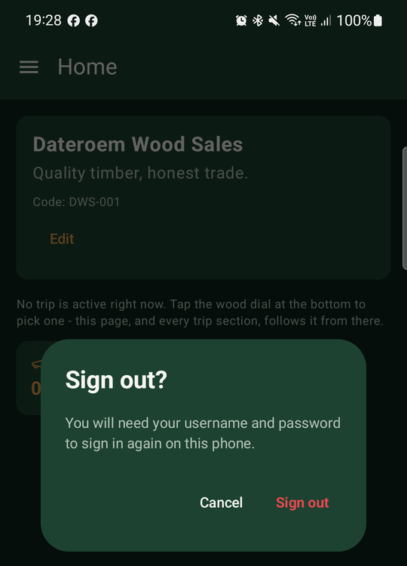
Figure 4: Sign out asks first
Where to adjust: Time in the background before the lock returns: LOCK_AFTER_AWAY_MS in ui/auth/AppLock.kt. Prompt wording: the same file. Messages shown after being signed out: SessionGuardInterceptor in data/network/RetrofitClient.kt.
Note: The fingerprint never leaves the phone and is not seen by the app: Android only reports whether the check passed.

9 Network settings
Item | Value and where
Server address | BuildConfig.MOBILE_SERVER_BASE_URL, set at build time in app/build.gradle.kts. Default http://127.0.0.1:8001/ (USB with adb reverse). For a shared APK: -PmobileBaseUrl=https://<public domain>/mobile-api/
Sign-in token | Stored with DataStore by SessionManager; added to every request as Authorization: Bearer by RetrofitClient. The token names this phone and works only while the phone stays approved.
Time-outs | connect 30 s, read 60 s, write 30 s (AI calls can take several seconds)
Plain HTTP | Allowed only for 127.0.0.1 and 10.0.2.2 (res/xml/network_security_config.xml); everything else must be HTTPS
Request logging | Full request and response bodies are written to the Android log (HttpLoggingInterceptor level BODY)

Caution: Full-body logging writes tokens and payment details to the phone's log. Lower it to BASIC or NONE in RetrofitClient.kt before a production release.

10 Building, testing and sharing

10.1 Testing on the USB phone
- Connect the test phone by USB with debugging allowed.
- Start the servers (desktop Servers section); it re-applies adb reverse tcp:8001 tcp:8001 (or run it by hand).
- Build and install the debug app from Android Studio (Run), or from a terminal (next section) followed by adb install -r app/build/outputs/apk/debug/app-debug.apk.

10.2 Command-line builds
Command-line Gradle picks up a Java runtime without jlink on this computer and fails. Use Android Studio's bundled runtime:
$jbr = "C:\Program Files\Android\Android Studio\jbr"
$env:JAVA_HOME = $jbr
.\gradlew --stop
.\gradlew assembleDebug "-Dorg.gradle.java.installations.auto-detect=false" "-Dorg.gradle.java.installations.paths=$jbr" "-Porg.gradle.java.installations.auto-detect=false" "-Porg.gradle.java.installations.paths=$jbr"

10.3 Sharing the app with admins elsewhere
- Test the change on the USB phone first.
- Build with the public address: add -PmobileBaseUrl=https://<public domain>/mobile-api/ to the assembleDebug command.
- Copy the APK to /root/fathersProject/downloads/dateroem-wood-sales.apk.
- Admins download it from https://<public domain>/downloadable/dateroem-wood-sales.apk and install it (allow installs from this source).

Note: The shared APK only works while the computer, the servers and the tunnel are running, because it reaches the mobile server through the tunnel.
Caution: Copies of the app built before 3 October 2026 have no phone key. They still accept the password, but every screen afterwards fails with "Please sign in again". Share a new APK and ask every admin to install it; each phone that was not the account's first then needs approval in the desktop app.

10.4 Before a production release
- Create a signing key (keystore) and build a signed release APK or App Bundle; keep the keystore and its passwords outside the project and backed up.
- Increase versionCode and versionName for every release.
- Turn request logging down, consider enabling code shrinking (isMinifyEnabled), and remove the plain-HTTP exception once the server has a permanent HTTPS address.
- Distribute through Google Play (internal testing track) or a device-management tool instead of a download link.

11 Development history
Date | Change
2026-09-12 | App connected to the mobile server; forest splash, icon and login; Products (create, edit, photo, bin); main menu; Marketing campaigns with video (paused campaigns hidden on the website).
2026-09-12 | Expenses with admin assignment of payments, Capital, Loans and Finance, heavy (bulk) orders, date pickers.
2026-09-13 | Back navigation, delivery (pickup) area management, product photos named after the product.
2026-09-14 | Trees, farmers and remainder trees; role-based sections; GPS coordinates filled automatically; trip finance.
2026-09-16 | Voice assistant for filling forms (continuous, Android speech), machine and vehicle pickers, product images in the app.
2026-09-19 | Orders section, floating chat button, side quests and reassignment of undelivered orders.
2026-09-20 | Bulk delivery editing, company-SIM M-Pesa SMS reading into the SMS queue, delivery signature.
2026-09-21 | Shared APK for admins elsewhere, working over the tunnel.
2026-09-25 | Painted-wood brand style (website, then mobile and desktop); delivery area shown on desktop order rows; USB phone link re-applied automatically.
2026-10-02 | Emojis replaced by line icons, tree-ring Products icon, spinning refresh buttons, clear feedback on server start and stop, secrets masked in server logs.
2026-10-03 | Fingerprint (or screen lock) required to open the app; product badge moved under the product name.
2026-10-03 | Choose the products a campaign promotes, in the phone app and in the desktop app (one request replaces the whole set and is written to the audit log).
2026-10-03 | Editing a campaign no longer drops its video; the app lock now covers the open screen instead of replacing it, so unsaved forms survive; unsaved campaign changes are kept as a draft.
2026-10-03 | Voice input asks for the microphone permission again (it had stopped silently); video campaigns show a still from the video in the campaign lists.
2026-10-09 | Retire a product: an admin takes a product off the shop from the desktop or phone app, whatever its stock, and can bring it back later; its stock and existing orders are kept. Products that run out of stock are listed for admins under "Needs attention", with a count on Products in the phone app menu.
2026-10-09 | Bulk order pictures: example photos of real bulk orders play as a slideshow on the website's Bulk Orders page (whole picture, optional caption, moves on every 5 seconds). Marketers, Admins and the SuperAdmin add, caption, put in order and remove them from Marketing in the phone and desktop apps; 12 at most.
2026-10-18 | The entrance in two real photographs instead of the drawn forest ("the board has seen it wise to use a real forest"): the old oak rising out of the dark, mist rolling in and clearing over a misty pine forest, then the company emblem and the wood wordmark; a tap skips it. Sign-in stands in the same forest. The app icon is the company emblem - the website's icon.
2026-10-18 | Calm error messages everywhere ("the user ... never gets the whole details but what is necessary and presentable"): the website, the phone app and the three servers show one plain sentence when the server is down, slow or has a problem - never addresses, codes or error text; the backend no longer sends stack traces; while a server is down the router shows a "We'll be right back" page (and the apps a short message).
2026-10-18 | The entrance plays again whenever the app comes back after more than 15 minutes, also when Android kept it in the background (Home or Back), over the screen the person was on.
2026-10-19 | The entrance plays every time the app is opened afresh, like Netflix ("waiting for 15 minutes is too long"), and after 3 minutes away when it comes back from the background; sign-in in the app's green wash, the entrance dissolving into it.
2026-10-20 | Turning the phone no longer rebuilds the screen, so it no longer asks for the fingerprint ("rotating a screen is not the same as closing the phone"); an app Android closed in the background still locks when it comes back. Sign out asks "Sign out?" first, in the menu and on the lock screen.
2026-10-24 | Home for Admins and the SuperAdmin shows the business at a glance ("superadmin in mobile cant seem to see the other details"): users by role, products, campaigns, trips and the orders waiting. A trip's profit and expenses are shown to Admins and the SuperAdmin only. The company card is kept on the server - the same on every phone - and only the SuperAdmin changes it (on the phone or in the desktop's Settings).

